High-Level Solution Design Document

For Amazon Application

# 1: Introduction:

The Amazon application serves as a comprehensive online marketplace, offering a vast array of products, services, and features to millions of users worldwide. At its core, the high-level design of the Amazon application focuses on scalability, reliability, and user experience. Leveraging a combination of microservices architecture, cloud computing, and cutting-edge technologies, the Amazon application seamlessly connects buyers and sellers, facilitates secure transactions, and delivers personalized recommendations to enhance customer satisfaction.

1.1. Purpose Of This Document:

The HLD describes the primary features of the system. It is best to list all the elements for clarity without going near the implementation details, as these are not for this audience.

1.2. Document scope:

Brief overview of the Amazon application and its significance anyone can read this document.

**2. Requirement Summary:**

1. User Authentication and Authorization:

- Secure user authentication mechanisms.

- Role-based access control for different user types.

2. Product Catalog Management:

- Ability to add, update, and remove products.

- Support for categorization and search functionality.

3. order Management:

- Cart management for users.

- Order placement, tracking, and cancellation.

4. Inventory Management:

- Real-time inventory tracking and updates.

- Automated alerts for low stock levels.

5. User Profile Management:

- Profile creation, editing, and deletion.

- Address book management for shipping addresses.

6. Review and Rating System:

- Ability for users to leave reviews and ratings for products.

- Moderation tools for managing reviews and ratings.

7. Security and Compliance:

- Implementation of security best practices to protect user data.

- Compliance with industry standards and regulations (PCI DSS, GDPR, etc.)

3.Assumptions and prerequisites:

This document outlines key assumption and fundamental elements integral to the design process of the Amazon application. The purpose is to ensure clarity and alignment among stakeholders regarding the fundamental principles guiding the platform’s development.

1. Device Compatibility: It is assumed that users will have reliable internet access to engage with smartphones, tablets, and computers, ensuring accessibility for a wide range of users.
2. Product Availability: The assumption is made that products showcased on amazon are readily available for ordering, maintain user trust and satisfaction.
3. Security Measures: Robust security measures will be implemented to safeguard user data and ensure secure transaction.
4. Server infrastructure: Availability of stable server infrastructure is a prerequisite to support platform operation.
5. Database Management: Amazon application depends on a reliable database management system for efficient data storage, retrieval, and management, ensuring seamless user experiences.

# 4.[**High-Level Design**](https://softwaredominos.com/home/software-design-development-articles/high-level-solution-design-documents-what-is-it-and-when-do-you-need-one/) **:**

It aims to provide process flow updates and information pathway changes using diagrams, tables, and other visualizations. Typically, also addresses integration issues with other systems. The HLD describes the primary features of the system. It is best to list all the elements for clarity without going near the implementation details, as these are not for this audience.

Features for Amazon Application:

1.User Management:

Components:

* + - * Frontend (Mobile/Web Interface)
      * Backend server
      * Database (User Information)

Flow:

* + - User registration, login, and authentication.
    - Profile management including address, payment methods, and preferences.
    - Social media integration for login.

2. **Shopping Cart and Checkout:**

Components:

* + - * Frontend (Mobile/Web Interface)
      * Backend server
      * Database (User Cart)

Flow:

* Shopping cart functionality for users to add, remove, and modify items.
* Seamless and secure checkout process with multiple payment options.
* Guest checkout and user account checkout with saved addresses and payment methods.

3. **Search and Navigation:**

Components:

* + - * Frontend (Mobile/Web Interface)
      * Backend server
      * Database (Product catalog)

**Flow:**

* + - Advanced search functionality with filters and sorting options.
    - Auto-suggestions and search history.
    - Navigation through categories and subcategories.

4. Order and Delivery:

Components:

* + - * Frontend (Mobile/Web Interface)
      * Backend server
      * Database (Product catalog)

Flows:

* + Provide users with a streamlined checkout process to place orders easily.
  + Collect necessary information such as shipping address, contact details, and payment method during checkout.
  + Display a confirmation message or page after the order is successfully placed, providing users with an order summary and order number.
  + Send email or SMS notifications to users confirming their order and providing details like expected delivery date and order tracking information.

5. Reviews and Ratings:

Components:

* + - * Frontend (Mobile/Web Interface)
      * Backend server

Flow:

* + - User reviews and ratings for products.
    - Moderation of reviews to prevent spam and maintain authenticity.
    - Aggregate ratings displayed on product pages.

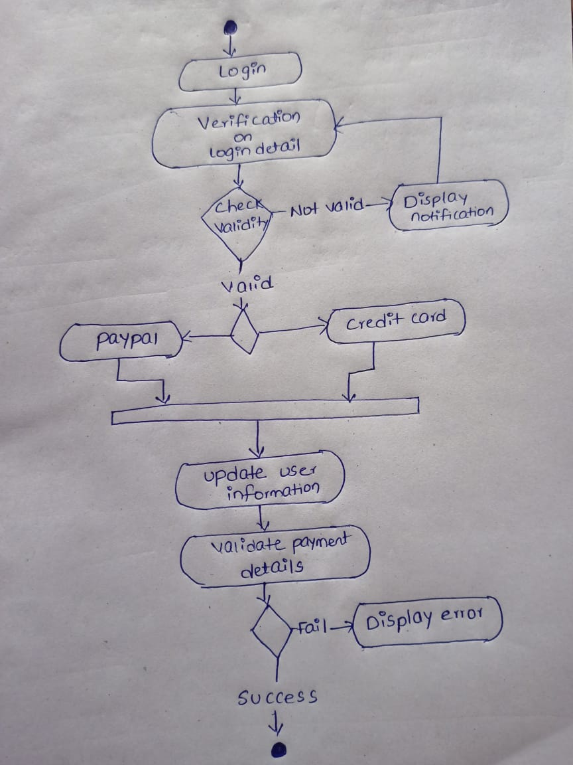

Fig: Flow between amazon application

Application Module:

1:Core system components: Amazon component are developed using java, leveraging the robustness and scalability of the language.

2: User interfaces: It tell the reader how users interact with the system or a particular component. The user Interface developed using HTML, CSS, and JavaScript for web interface.

3: The database Layer: The database layer of Amazon application utilizes a relational database management system (RDBMS) such as MYSQL for structured data storage.

4:***Application Programming Interfaces (APIs)*: These** are essential to call out so that inter-platform dependencies are vividly illustrated.

#### Data Flow and Use Cases:

The data flow and use cases section document all necessary interactions between the user and the system.

1: User Management Flow:

* + - User registration, login, and authentication.
    - Profile management including address, payment methods, and preferences.
    - Social media integration for login.

2: Shopping cart and checkout flow:

* Shopping cart functionality for users to add, remove, and modify items.
* Seamless and secure checkout process with multiple payment options.
* Guest checkout and user account checkout with saved addresses and payment methods.

3: **Search and Navigation Flow:**

* + - Advanced search functionality with filters and sorting options.
    - Auto-suggestions and search history.
    - Navigation through categories and subcategories.

4: Order and Delivery flow:

* + Provide users with a streamlined checkout process to place orders easily.
  + Collect necessary information such as shipping address, contact details, and payment method during checkout.
  + Display a confirmation message or page after the order is successfully placed, providing users with an order summary and order number.

5: Review and Ratings Flow:

* + - User reviews and ratings for products.
    - Moderation of reviews to prevent spam and maintain authenticity.
    - Aggregate ratings displayed on product pages.